Assignment 01:- Understanding of Hardware and Its Components.

**Section 1: Multiple Choice**

1. Which of the following is NOT a component of the CPU?

Ans :- 2. RAM

1. What is the function of RAM in a computer?

Ans :- Ram temporary Store Data and CPU Processes While the PC is On or Working. It Works fast And Perform Smooth.

1. Which of the following is a primary storage device?

Ans :- 4. 1 and 2 both (HDD and SSD).

1. What is the purpose of a GPU?

Ans:- A GPU (Graphics Processing Unit) is used to render images, videos, and animations. It Allows to Process Task like Playing Games, Video Editing, Animation, ETC.

**Section 2: True or False**

1. The motherboard is the main circuit board of a computer where other components are attached.

Ans:- True

1. A UPS (Uninterruptible Power Supply) is a hardware device that provides emergency power to a load when the input power source fails.

Ans :- True

1. An expansion card is a circuit board that enhances the functionality of a component**.**

**Ans :- True**

**Section 3: Short Answer**

1. Explain the difference between HDD and SSD.

Ans :- HDD

-HDD stands for hard disk drive.

-HDD Store Data in spinning Disk.

-read letency time is high.

-HDD have moving parts and subject to sudden failure.

SSD

-SSD stands for solid state drive.

-random access time 0.1ms.

-read letency very low.

-SSD have no moving parts to fail.

10. List and briefly explain three input devices commonly used with computers.

Ans :- There Are 3 Comman Input Device :

1. Keyboard
2. Mouse
3. Microphone
4. Keyboard :-

-The keyboard is a fundamental input device used to enter text and commands into a computer.

- It Has Various Keys including letters, numbers, symbols, and function keys.

- It Have 96 to 104 Keys.

2. Mouse :-

-The mouse is a pointing device that allows users to control the cursor on the screen.

-The Pointer of the mouse is called coursor.

-  It is used to select items, navigate menus, and perform actions within a computer program.

3. Microphone :-

- A microphone is an input device that converts sound waves into electrical signals.

- it allowing users to record audio or input speech.

- It is commonly used for voice communication, recording audio, and speech recognition.

**Section 4: Practical Application**

1. **Identify and label the following components on a diagramof a motherboard:**

**Ans :-**

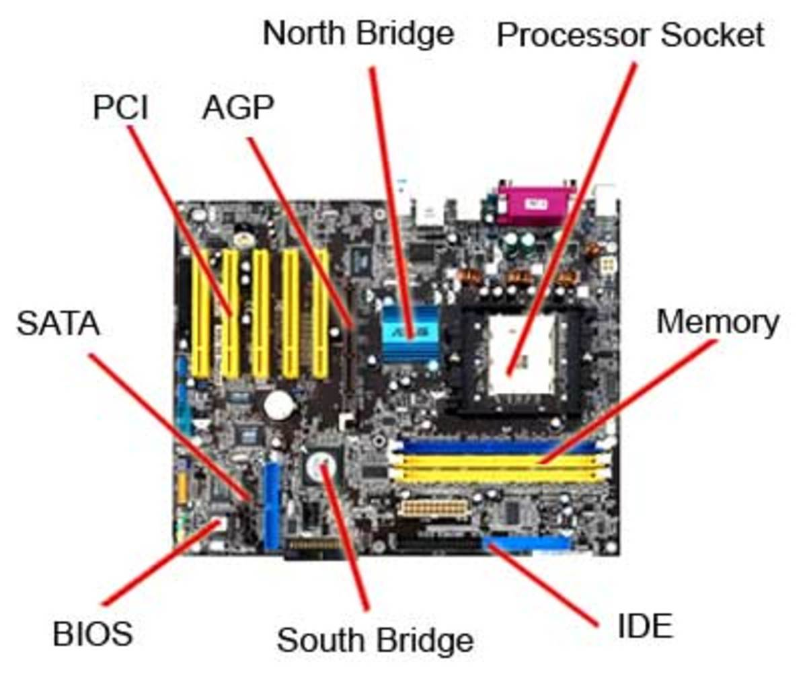

- **CPU Socket**: This is where the processor (CPU) is installed. It's usually centrally located.

- **RAM Slots**: These are long slots near the CPU socket used to install system memory (RAM).

- **SATA Connectors**: Found on the side/bottom-right area of the motherboard; used to connect SSDs, HDDs, and optical drives.

- **PCI-E Slot** – Long slot used to connect expansion cards like a graphics card (GPU). There may be multiple, but the primary one (x16) is used for GPUs.

1. Demonstrate how to install a RAM module into a computer.

Ans :- Process to Install a RAM :

* ensure the computer is off and unplugged.
* Locate the RAM slots on the motherboard.
* Push the **retention clips** on both ends of the RAM slot **outward.**
* Line up the **notch** on the RAM stick with the **ridge** in the slot.
* Press the RAM module down **firmly and evenly** until the clips snap back into place.
* Close the case and power on the pc.

**Section 5: Essay**

1. Discuss the importance of proper cooling mechanisms in a computer system. Include examples of cooling methods and their effectiveness.

Ans :- Proper cooling is **essential** in a computer system to ensure **stable performance**, **longer component life**, and **protection against hardware damage**.

Importance of Cooling System :

* **Prevents Overheating :-** Overheating can cause **thermal throttling**, where the CPU/GPU reduces speed to cool down.
* **Increases Lifespan of Components :-** High temperatures degrade hardware faster.
* **Improves Performance :-** Cooler systems can run at full capacity for longer periods.
* **Ensures System Stability :-** Prevents random shutdowns, freezes, and system errors.

There Are 3 types of Cooling System :

1. Air Cooling
2. Liquid Cooling
3. Passive Cooling
4. Air Cooling :-

* Uses fans and heatsinks to dissipate heat.
* Air cooling is relatively inexpensive and easy to implement but can be less effective for very high-performance systems.

1. Liquid Cooling :-

* Uses liquid coolant in tubes and a radiator.
* Improves heat transfer efficiency.

1. Passive Cooling :-

* Uses metal heatsinks without fans.
* Passive cooling is simple and silent but less effective for high heat loads.

1. Explain the concept of bus width and its significance in computer architecture.

Ans :-

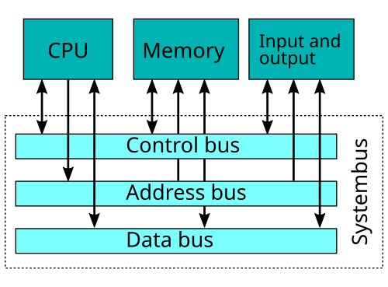

There Are 3 types Bus :

1. Address Bus
2. Control Bus
3. Data Bus
4. Address Bus :-

-This Bus is Indentifies The Specific Location of the data in memory or I/O device.

- It carries the memory address from the cpu to other component.

- It’s Unidirectional.

1. Control Bus :-

- It carries the Controal Signals from the cpu to other component.

- It’s Bidirectional.

- Such as Read/Write signals.

1. Data Bus :-

- It bus carries the Acttual Data being transferred between the cpu and the other component.

- It’s Bidirectional.